LAB EXAM 1

TASK 1:

WRITE A COMMENT PROMPT WITH 2-3 EXAMPLES ASKING COPILOT/GEMINI TO GENERATE A PYTHON FUNCTION THAT CHECKS WHETHER A STRING IS A PALINDROME .

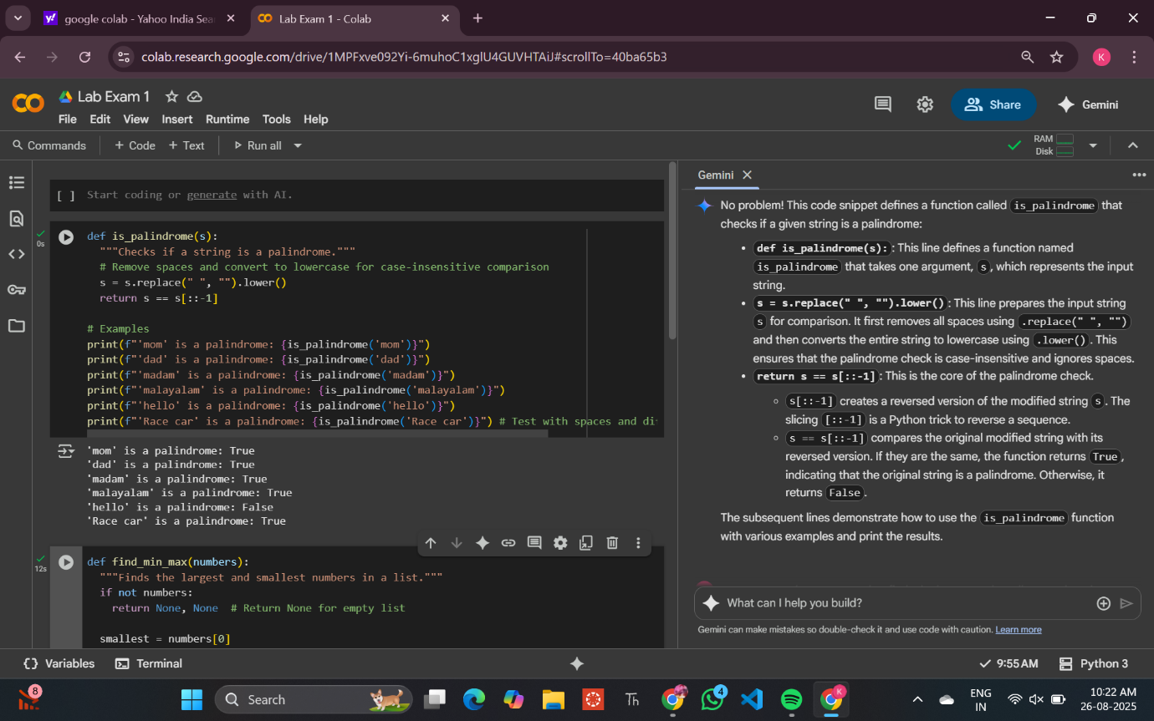

TASK 2 :

ASK GOOGLE COPILOT / GEMINI TO GENERATE A PYTHON PROGRAM THAT FINDS THE LARGEST AND SMALLEST NUMBERS IN A USER-PROVIDED LIST. THEN , ASK GEMINI TO EXPLAIN HOW THE CODE WORKS.

